Meet the New Thought Teachers
With Rev. Dr. Ruth Miller

Emma Curtis Hopkins
Charles & Myrtle
Fillmore
Emilie Cady
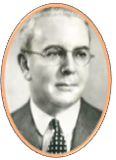
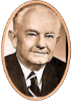

Emmet Fox
Mary Baker Eddy
Ernest Holmes

2nd Wednesday of Each Month
Noon - 1:00 p.m.
Rev. Dr. Ruth Miller introduces the teachers of the science of applied metaphysics called New Thought. 1 teacher, 1 hour, 1 time a month.

